Hello! You might find it useful to review the video on the last task sheet. I have added some hints to help you and remember, each box in a punnet square shows a possible combination of the offspring’s alleles.
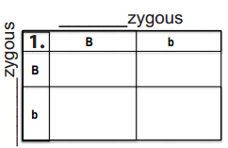
Tasks
- Complete the punnet squares

- Colour in the boxes showing the offspring’s eye colour.

- Identify the parents as either homozygous or heterozygous.

- Answer the eye questions

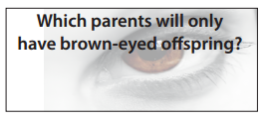

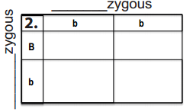
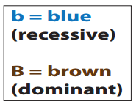

HINTS
Same letters = HOMOZYGOUS
Different letters = HETEROZYGOUS

Capital letter = DOMINANT genes
Little letter = RECESSIVE gene
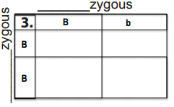
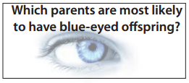

Exam Practice
Long whiskers are a dominant trait in cats. What percentage of offspring is expected to have short whiskers from the cross of two long whiskered cats, one that is homozygous dominant (LL) and one that is heterozygous (Ll).

(3 marks)
Success Criteria
1 Mark – Correct completion of punnet square diagram
1 Mark – Determination of the possible phenotypes (in this case, type of whisker)
1 Mark – Determination of the percentage offspring with short whiskers.
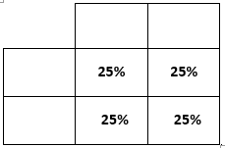
Remember, each square is equivalent to 25%
For total % just count the squares

