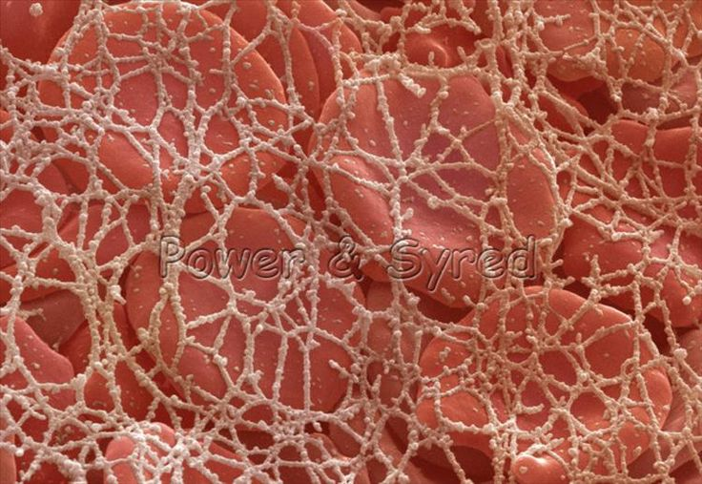
Title: The Blood

Watch the following video and/or read the text below and answer the following questions. https://www.youtube.com/watch?v=nc_kbfjhiUo

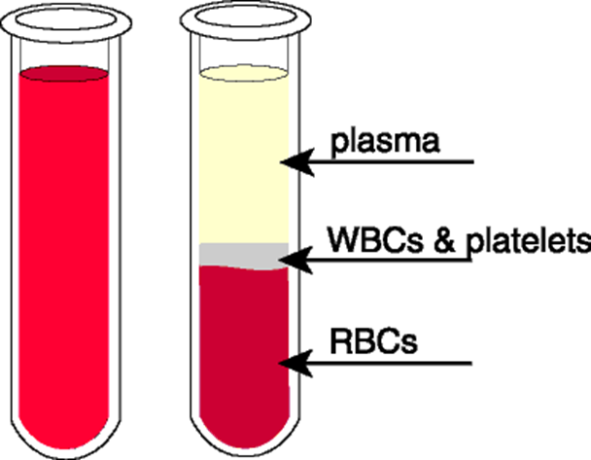
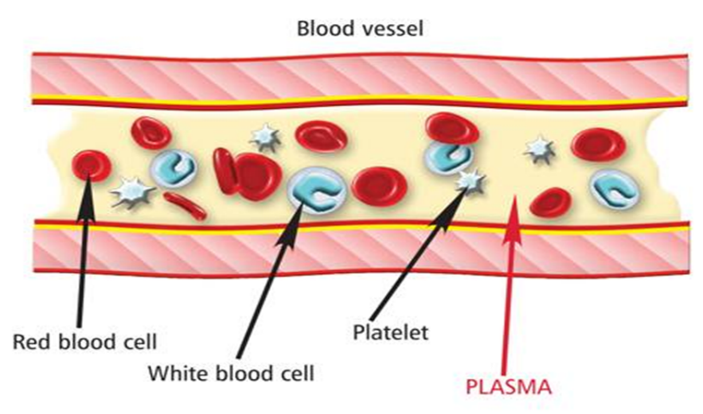
Blood is made up of 4 main components, red blood cells, white blood cells, plasma and platelets.

Plasma is a straw-coloured liquid, in which all the other cells are suspended. It
Also contains vitamins and hormones. Red blood cells contain haemogloblin and
carry oxygen around the body and carbon dioxide to the lungs. There are different
types of white blood cells in the blood which are all part of the immune system,
protecting the body from infection. Platelets are fragments of cells that help
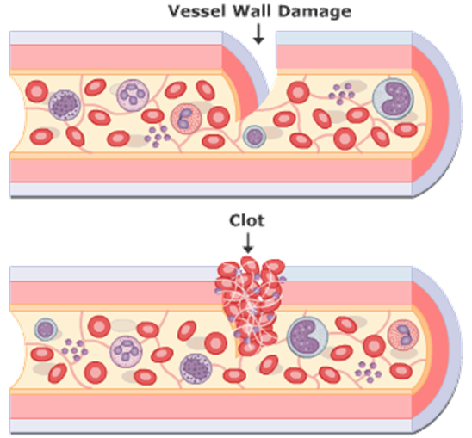
the blood clot and form a scab when you get cut.
Some people are given platelets if they have been hurt to help wounds heal or given blood to replace blood they may have lost.

GREEN: List the components of blood

AMBER: Describe the function of each component of blood.

RED: Suggest some uses for blood products

